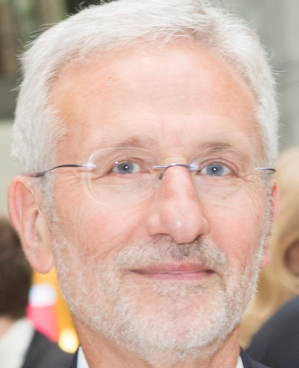

CURRICULUM VITAE

Carmine Zoccali
Born 27-1-1947

Dr. Zoccali is a specialist in Renal Diseases (Pisa University) and Hypertension (Hypertension specialist, board certified by the European Society of Hypertension and European Society of Cardiology). He was trained in Internal Medicine (Messina University), Hypertension (Glasgow MRC Blood Pressure Unit) and Clinical Epidemiology.

Past Appointments
-Past Director, Division of Nephrology, Hypertension and Renal Transplantation Ospedali Riuniti, Reggio Cal,
-Past Director, CNR-IFC Clinical Epidemiology and Pathophysiology of Renal Diseases and Hypertension

Present Appointment
Associated Clinical Investigator at the CNR-IFC Clinical Epidemiology and Pathophysiology of Renal Diseases and Hypertension

Teaching activities
National (Italian) Qualification to Full professorship of Nephrology
Past Professor of Nephrology at the School of Nephrology (postgraduate) of Palermo, Catania and Messina Universities.

Publications, international scientific scores
As of August 12th 2020, dr Zoccali has published over 750 papers in peer-reviewed International Journals indexed in Pubmed. Publications by dr Zoccali have been quoted 40523 times (17675 from 2015) and at this date the Hirsh index of dr. Zoccali is 103 (Google Scholar). His ResearchGate score 53.37 (higher than 97.5% of all investigators included in ResearchGate ).

As of August 12th 2020, according to EXPERTSCAPE, http://expertscape.com/ex/chronic+kidney+failure, a scoring system for investigators maintained by the John Hopkins University (Baltimore), dr Zoccali ranks as the first European expert on chronic renal insufficiency (the 4th on a world scale) and also the first European expert on Kidney Failure (the 5th on a world scale).

Scientific Congresses
Dr Zoccali has been invited speaker at all major Nephrology and Hypertension Congress (over 500 lectures and seminars) including the ERA EDTA, The American Society of Nephrology, the International Society of Nephrology, The American Heart Association, The European Society of Hypertension, the European Society of Cardiology and several major Societies of Nephrology and Hypertension.

Editorial Appointments
-Editorial Board member Clinical J Am Soc Nephrology
-Editorial Board member American Journal of Kidney Diseases
-Editor Emeritus Nephrology, Dialysis and Transplantation
- Editorial Board Member Hypertension
-Editorial Board member Journal of Hypertension
- Associate Editor European Journal of Clinical Investigation
- Editorial Board member Clinical Nephrology
- Editorial Board member Blood Purification
- Academic editor PlosOne (Public Library of Science, National Institute of Health)
- Editorial Board Member BMC Nephrology
-Editorial Board member Turkish Nephrology, Dialysis and transplantation Journal
-Editorial Board member Revista Portuguesa de Nefrologia
- Member of the 1000 Faculty, Biomed Central
-Editorial Board member Journal of Clinical Medicine (Nephrology and Urology)

- Past Chief Editor Nephrology, Dialysis and Transplantation (2011-2017)
-Past Editorial Board member J Am Soc Nephrology (till December 2017)
-Past Editorial Board Member, Kidney International (2006-April 2014)
- Past Deputy Editor, Journal of Nephrology
- Past Subject Editor (Hypertension), Nephrology Dialysis and Transplantation (2001-2011)

- Referee to : New England Journal of Medicine, Lancet, Circulation, Archives of Internal Medicine, Atherosclerosis Thrombosis and Vascular Biology (ATVB), Atherosclerosis, Journal of American Society Nephrol, American Journal of Kidney Disease, Kidney International, Nephrology Dialysis and Transplantation, Hypertension, American Journal of Hypertension, Journal of Hypertension, Blood Pressure

Scientific Societies
Immediate Past President of The ERA EDTA (2017-2020)
Past Chairman of the Registry of dialysis and transplantation of the ERA-EDTA (2003-2009)
Founding chairman of the EUROPEAN CARDIOVASCULAR AND RENAL MEDICINE working group (EURECA-m) (2010-2012)
Past President of the Italian Society of Nephrology (2007-2008)
President of the Scientific Committee of the XLIX Congress of the ERA-EDTA (Barcelona 2007)
Council Member of the European Dialysis and Transplant Association and Renal Association (EDTA-ERA) 2000-2009 and 2011-2017
Member of the EDTA-ERA paper selection committee (1993-1995, and 1999 on)
Councillor of the Italian Society of Hypertension 1998-2001
Secretary Treasurer Italian Society of Nephrology 1997-1998.
Board Member of the Council of the Italian Society of Hypertension (2009-2011).
Member of the Scientific Advisory Board of the Italian Registry of Dialysis and Transplantation (1996-2003) and Chairman of the Calabria’s Regional Dialysis Registry.

Guidelines, Methodology
European Best Renal Practice (ERBP) committee of the ERA EDTA Board member
Board of Directors member , Global Guidelines in Nephrology (KDIGO, American Kidney foundation) 2002-2009
Member of the Faculty of 1000 (BioMed Central)
Past chairman of the Guidelines of the Italian Society of Nephrology

Grant review consultancy/refereeing
British Kidney Foundation
Scottish Kidney Foundation
MRC Medical Research Council
Welcome trust
Dutch Kidney Foundation
Consultant to CINECA (the body supervising grants awarded by the Ministry of Research and Education in Italy)
Past Referee Continuous Medical Education Ministry of Health Italy

International Awards and honorary membership and fellowships
-Doctor Honoris causa, University of Patras-Greece (October 5th , 2019)
-Doctor Honoris causa, University of Oviedo-Spain (September 22nd , 2018)
-Richard Yu Endowment award of the Hong Kong Society of Nephrology (September 30th, 2018)
-International Award of the American Kidney Foundation (2003)
-International G.A. Borelli prize (2004)
-Honorary member of the Polish Society of Nephrology (2007)
-Honorary Member of the Spanish Society of Nephrology (2008)

-Fellow of the American Society of Nephrology (FASN) 2008
-Fellow of the National Kidney Foundation (FNKF) 2010
-Fellow of the European Renal Association and the European Dialysis and Transplantation Society (FERA) 2010
-Dorso Prize (2010)

Member to:
-European Society of Dialysis and Transplantation and European Renal Association.
-American Society of Nephrology
-International Society of Nephrology
-International Society of Hypertension
-European Society of Hypertension
-American Society of Hypertension
-Societa' Italiana Nefrologia
-Societa' Italiana Ipertensione Arteriosa

